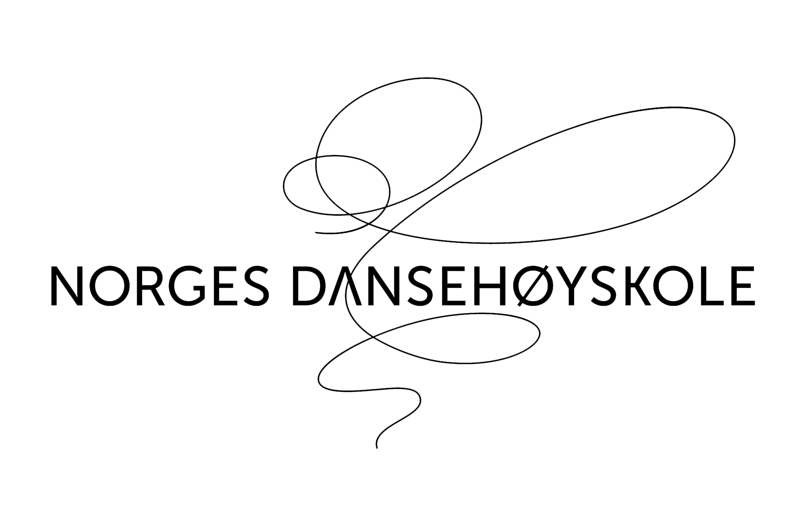

Dok I D : 1.4.1-2 application deadline is:
Revisjon : 02.01.2017 ChSa March 1st. 2017

Application for admission 2017, non-scandinavians

Surname(s)
Forename, middle name
Date of birth: day month year
Gender: | Female ☐  Klikk her for å skrive inn tekst. |  |  |  |  |  | Male ☐  Klikk her for å skrive inn tekst.
Nationality
Country of residence

How long have you resided there?
Street address
Postal code, city / town, country
Mobile / cell phone (inc. Country code)
E-mail address
Desired Major: mark the box |  |  |  | Jazz ☐  ☐ |  |  |  |  | Moderne / samtidsdans☐  Klikk her for å skrive inn tekst.
Place of audition: mark the box |  |  |  |  | Oslo ☐  Klikk her for å skrive inn tekst. |  |  | Bergen ☐  Klikk her for å skrive inn tekst. |  |  | Trondheim ☐  Klikk her for å skrive inn tekst.

If you cannot attend an audition you may send in an audition video please see our web site www.ndh.no
Video is sent on a usb-card: ☐  Klikk her for å skrive inn tekst. |  |  |  |  |  | Video is uploaded to a drop-box solution: ☐

.
Place a frontal picture of your face
(from the shoulders and upwards)
in the box on the left, or send it separately

Name and address of the school you graduated from | Attendance, from - to

Secondary education : High school, gymnasium or equivalent

Higher education (college, university, vocational, etc.)
Name and address of the school you graduated from | Attendance, from - to

School name and address
Course of study |  | Total terms studied |  | How many classes per week, average | Attendance, from - to
Teacher(s)

Dance education

School name and address
Course of study |  | Total terms studied |  | Course of study | Total terms studied
Teacher(s)

School name and address
Course of study |  | Total terms studied |  | Course of study | Total terms studied
Teacher(s)

School name and address
Course of study |  | Total terms studied |  | Course of study | Total terms studied
Teacher(s)
(if you need more space for any of the questions in this application you may write more at the end.)

Employer, address, type of work | employed from - to
Relevant work experience

Cultural, artistic, sports, social interests, hobbies etc.
Interests

Other schools you have applied to

Please tell us where you heard /read about our college

Do you have any health issues that would affect your ability to follow a rigorous physical regimen? If so please specify. Do you have any conditions that the college should be aware of in order to assist you should the need arise? Please specify?
Health statement

Briefly explain why you'd like to attend our college, and what you'd do with your education
Other comments

Extra text if you need to continue from any of the questions above:

Application form and Documents to be sent /brought to the audition:

Notarized transcript of grades |  | Sent ☐ |  |  | will bring to audition ☐
If you are in the last year of secondary education and have not received your final grades, please upload the transcripts from the terms you have completed.

Notarized transcript first year |  |  |  | Sent ☐ |  |  |  | will bring to audition ☐
Notarized transcript second year |  |  |  | Sent ☐ |  |  |  | will bring to audition ☐
Notarized transcripts from other education |  |  |  | Sent ☐ |  |  |  | will bring to audition ☐
A picture of your face is inserted on the first page? |  |  |  |  |  | Yes ☐ | No ☐ |  | -or sent separately ☐

Passport must be brought to audition so we can copy relevant pages.

(Applicants without passport will NOT receive a reply after audition before it is produced.)
Do you have other attachments: | Yes ☐ |  | No ☐ |  |  | Which attachments? (explain in the next line)
Language requirements:
Norwegian is the official teaching language at the college, and all students are expected to speak, read, and write fluently before attendance commences (Danish/Swedish are accepted for written work). Immediately upon admission students must enroll in a level 1 Norwegian language course, which is offered at different venues (our school does not offer language courses.) Students are entirely responsible for their language training. Requirements are as follows:
In order to commence studies in August: You must be enrolled in level 1 course.
In order to take exams at end of spring term: You must be enrolled in level 3 course
(you must have passed exams level 1 and 2)
(Please see our website for more information on these requirements.)

__________________________________________________________________________________
Documents must be in WORD or PDF formats. You may send all documents in an e-mail to info@ndh.no
or
You may send all documents in paper by mail to our address below. Be sure they arrive here by the application deadline!
Norwegian College of Dance, NDH
Post office box 2956 Toyen,
0608 Oslo, NORWAY

For more information see www.ndh.no or contact us at: info@ndh.no - telephone (+47) 23 24 18 00.

